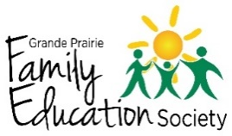
Learner Evaluation Form

We hope this Literacy program has been helpful for you in finding new ways to play and learn with your child(ren). Thank you for helping us improve our program by filling in this form! Please complete both sides of the form.

- What new skills have you learned while attending this program? (1.2a)

- How have you used these new skills in your everyday life? (1.2a)

- What progress do you feel you have made in your learning? (1.2b)

- Do you feel your self-confidence has increased as a result of participating in this program? Why or why not? (1.2c)

- Did you learn what you wanted/ needed to from this program? (2.2a)
Yes / No

If not, what could we have done differently to ensure you learned what you needed to?

- Did you feel comfortable attending this program? (2.2b)
Yes / No

If not, what could we do differently to ensure that all people feel welcome attending these programs?

- What other ways have you benefited from attending this program?

- Anything else you would like to share?

Can someone with the Grande Prairie Family Education Society Literacy Program contact you to follow up or gather further feedback?

No ___

Yes ___ Please provide preferred contact #: __________________________________

